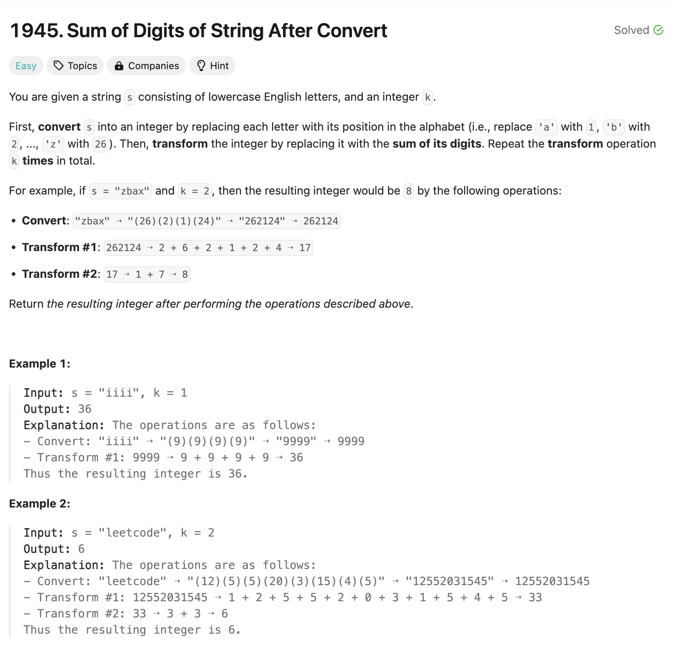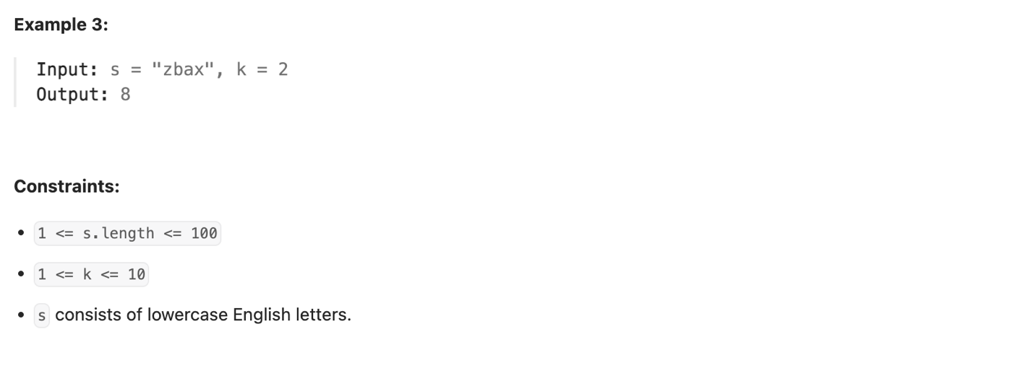  
  
Solution:-   
class Solution {

public int getLucky(String s, int k) {

// Convert each character to its numerical value and build a string

String numericString = "";

for (char ch : s.toCharArray()) {

numericString += Integer.toString(ch - 'a' + 1);

}

// Apply digit sum transformations k times

while (k-- > 0) {

int digitSum = 0;

for (char digit : numericString.toCharArray()) {

digitSum += digit - '0';

}

numericString = Integer.toString(digitSum);

}

// Convert the final string to integer and return

return Integer.parseInt(numericString);

}

}